Walk difficultly - moderate to hard – trainers or stout shoes required (unsuitable for wheelchairs) allow 1.5 hours to enjoy the Cove walk and 5 hours if taking the extended route of a more difficult nature.

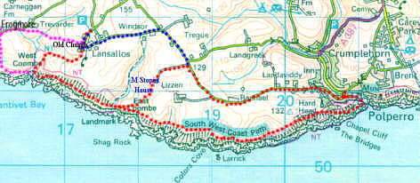
The parish of Lansallos, anciently called Lansalewys, is situated in the deanery and Hundred of West. It is bounded on the north by Pelynt, on the east by Talland, on the south by the sea, and on the west by Lanteglos-by-Fowey and Lanreath. The parish name means 'Church site (lann) of unknown name'. Lansallos is a small village on the south coast of Cornwall between Fowey and Polperro situated above the scenic Lansallos Cliffs.
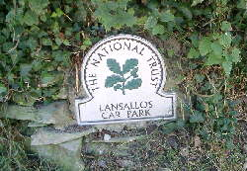
The walk begins in the large National Trust car park at Lansallos which operates a small car parking charge on an “honesty box” basis. This is only a small charge but does go to help upkeep the paths for your enjoyment. Turning left out of the car park you walk a short distance down the lane towards the church and to the left around the bend in the road are public toilets just a few metres along from the beautiful old Lansallos church. There are no other facilities until you return or head to Polroun so be warned.
It is well worth enjoying the church either before you begin your walk or on the way back as it is steeped in interesting facts and history. The following notes will help you enjoy your visit. The walk instructions continue immediately after the Church History below.

Church History
The present church was dedicated in 1321. However, about a hundred years afterwards such extensive reconstruction was undertaken, including the aisles and the tower, that one wonders whether it should not be called a fifteenth century church. The present church succeeded a Norman church on the same site and before that there had been a Celtic establishment. The place was the "Ian" or monastery of St. Salwys, about whom nothing is known. He probably lived some time in the 9th century. (In the Domesday Survey the manor of Lansalhas is one of the 288 manors given to the EarI of Morteton.)
Although St. Salwys gave his name to the parish of Lansallos, the church is dedicated to St. Ildierna, about whom, again, nothing is known. We are not even sure whether the saint was a man or a woman. William of Worcester, a chronicler who wrote an account of his peregrinations, says that when he was in Fowey in 1478 he heard that "Saint Hyldren, a bishop, lies in the parish of Lansalux, near the parish of Lanteglys; his feast is held on the first day of February, that is on the vigil of the Purification of the Blessed Mary.’ He believed that the body of the Bishop was buried before the High Altar. However, there are other and earlier documents which lead the authorities to conclude that the church was dedicated to St. Ildierna, a Virgin. When the church was restored, the choir was excavated to a depth of some feet but no remains of a bishop or of anyone else were discovered. There were found, however, some decaying pieces of the Rood Screen and also the mutilated stone effigies of a knight in mail armour and his lady which now lie near the main door. They were probably members of the Hywys family who were lords of the district in the 14th century. Their fortified manor was at Raphael on the site of which there is now an old farmhouse. Under the chancel was also found the slate coffin slab which we call the Elizabethan Lady and which is now fixed to the south wall. She is in farthingale, pointed stomacher and ruff. She was Margery Smith, buried here in 1577 and married first to Phillip Buttonhead and then to a gentleman of Tregunnick, near Seaton. Why the slate slab should have been buried is a mystery. The Reformation Settlement was concluded by 1577 so no question of sacrilege was involved.
To return for a moment to St. Salwys: there is a story of a monk's ghost which walks down the church and across the churchyard. This is probably a folk memory which has survived nearly a thousand years and a change of language. There have been no monks in Lansallos since the Norman Conquest. You may be sure that Lansallos Church is not haunted. At whatever time one enters, there is always a feeling of peace and holiness.
The font comes from the earlier Norman Church. The marble pillars supporting it are Georgian, an anachronism, but rather a charming one in effect. Behind the font is the oldest monument in the church - half a Celtic font buried in a field at Highertown Farm. It may have been the original font that St. Salwys used over eleven hundred years ago.
The Bells of Lansallos are a very fine peal of eight put in by the Rev. N. Rivers-Tippett. then Rector of the parish, in 1937. Originally there were three medieval bells but they were broken up early in the nineteenth century by drunken villagers. For a hundred years Lansallos folk were summoned to church by the cracked bell that survived and which now stands near the door. The Gothic lettering-Sancta Margareta ora pro nobis-and the chevrons and trefoils, laver pots and a cross crosslet are very curious. Not far away from this bell can be found the five-holed stocks.
The benches were made between 1490 and 1520. The carvings on the ends are largely Renaissance scroll-work in a Gothic framework. Some are heraldic. One represents the Blessed Trinity:- a full face and two profiles, making the symbol peculiarly effective. One bench-end by the door shows a negroid face having its nose pecked off by a mythological bird. They all deserve inspection one by one, as even where the scroll-work appears conventional, extraordinary animal heads and bodies have been worked into the designs.
The church has no vestry. The west end of the north aisle, (or rather half-aisle), is used instead. At the entrance to this 'vestry" there are the first few of the bricked-up steps which led to the rood loft over the great screen which no longer exists. A slate oval memorial slab now covers the entrance to the loft. In Cornwall the rood screen generally extended the whole width of the church and not, as in England, across the entrance to the chancel alone.
The head of an ancient Celtic cross which was dug up in a field can now be found in the churchyard. Towards the church gate, on the right hand side, there is an 18th century tombstone commemorating an unfortunate smuggler killed by a cannonball. He is either buried here or in Talland: his sorrowing relatives had an identical slate put up there.
It has had its vicissitudes in recent years. In 1923 the tower was struck by lightning; one of the dislodged pinnacles was later used as a base for the pulpit. The church was struck by shrapnel in the night of 11th June 1941 and the roof was pierced during a combat between British and German aeroplanes. Thank God. only slight damage resulted. The church was again preserved in July 1949 when the organ was destroyed by fire. In the summer of 1975 the church tower was again struck by lightning, disproving the old adage that it never strikes in the same place twice. This time the north-west pinnacle completely exploded and the electric switch panel was ripped off the wall. The bells were silent for a year until the tower was repaired. Each pinnacle is now fitted with a lightning conductor, used by the rooks for their balancing acts. During the hurricane of January 1990 the roof was badly damaged and the cross surmounting the gable-end of the south aisle and the cross over the porch were destroyed. In March of 2005 local youths started a fire that destroyed part of the roof this is currently being repaired
Continue your walk down a narrow road just to the east (left) of the church and a few yards down follow a footpath finger sign which directs you downhill along a track, enclosed by trees right down a long valley called West Coombe leading to the sea just under a kilometre to the south west.
Downhill it is easy going down this track, returning up it after a long walk it is a completely different matter.
Keep to the paths moving left and DOWNHILL all the time. However halfway down you will see the path split and you may either continue down or turn right over the bridge. This will lead you though a wicket gate and down over the fields to the Cove.
You will soon emerge out of the tree-enclosed track through a gate and will see the sea dead ahead with the small beach, and the South West Coast path spiraling away to the East and West. Experienced walkers and more energetic may at this point head East to Polperro, a charming fishing village about 3 and half miles distant, or West to Polroun with its staggering views over Fowey natural Harbour.. This walk extension is described below: For those less energetic a relax on the beach and the return journey is as described above in reverse.
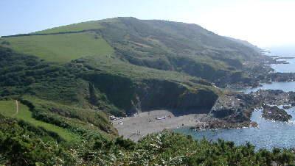
For the Cove continue down the steep narrow path for about 200 yards. The waterfall on the right is the stream we crossed earlier and runs over and under the sand to the sea.
For the Polruan extension make your way down to overlook the beach and take the Coast Path West (Right), across a small bridge and over the first of several stiles, some quite big too, which you will encounter on the walk.
Once across the stile there is a steep little ascent up the coastal path, again the first of several ups and downs to be overcome on the SW coastal path to Polruan and the river Fowey.
It is only a short climb out of the valley and looking back you will see just how nice the beach is on such a calm sunny day.
It is known as Lansallos Beach and one of a few along this small section of coast called Lantivet Bay. .
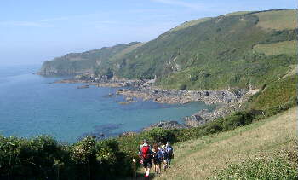
Lantivet Bay stretches west from south of Lansallos right across to Pencarrow Head, a good spot for a meal break.
It is about 2 km from Lansallos Beach across west to Pencarrow Head but after the first uphill section it is relatively flat and easy walking.
The photograph on the right shows the area of coast right across to Pencarrow Head and a really beautiful section of rocky coast it is too. The going is easy along this section, relatively flat in comparison to what is ahead west of Pencarrow Head.
At this point it is a level wide coastal path and before long we reach Pencarrow Headland where the views both east and west on a day with good visibility are quite magnificent.
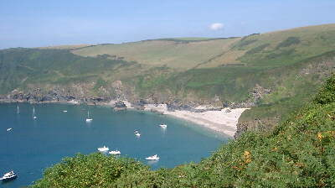
After your break make your way north following the coast as it curves along the eastern edge of Lantic Bay to a high point 400 feet above the wonderful beach way below you.
On a lovely day such as this when the picture was taken you could easily be on a Greek Island with the many boats moored up just offshore from the wide sandy beach with many (people) on it swimming and enjoying themselves to the full.
Whereas the section of coast in the Lantivet Bay area is relatively level, the coast path around Lantic Bay most certainly is not.
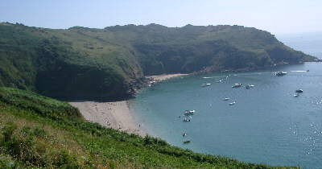
From Pencarrow climb up from 150 ft to approaching 400 ft then from the high point descend down to just 100 ft above Lantic Beach and then up again to a height of 360 ft above Blackbottle Rock and from there more or less down again into Polruan and right down to sea level.
The descent from the highest point high above the east end of Lantic Beach down to the middle of the beach was exceedingly steep and can be slippery at certain times of the year.
As you climb up so the views of Lantic Bay change but brilliant they most certainly are and will leave lasting memories in the minds of the walker.
It is almost all downhill from there into Polruan, but not quite.
Descend (no need for down as you can’t descend any other way) to go round the headland leading to the entrance to the River Fowey and then a short sharp climb of 130 feet ascent from crossing a stream to walking across a grassy sward and the houses at the south east end of Polruan.
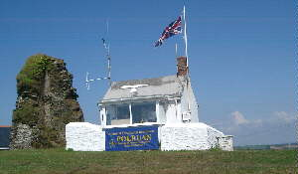
The entrance to Fowey harbour is quite narrow and after going along a narrow lane walk along in front of what once was a coastguard lookout. This is still used by worthy volunteers from the National Coast Watch Institution who keep local lookouts at various points along the coast.
As far as I can see the next Coast Watch point east along the coast is at Rame Head, some 15 miles away.
Across the entrance to the river Fowey on the other side you will see Readymoney Beach,
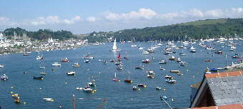
The coastal town of Fowey sits on the far bank of the river with the quiet village of Polruan on the East Bank and you can descend (ditto comment above) into the village itself.
Once again a wonderful panorama of Fowey deep water harbour and the hundreds of boats moored up in the harbour, wonderful views.
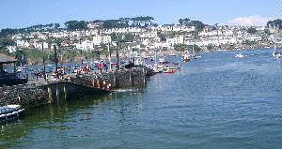
Walk down right to the small harbour of Polruan and at most times of the summer you will see on the quay kids leaping into the river to cool off and a number of boats plying their trade in taking passengers for a trip up the river as well as the Polruan to Fowey passenger ferry which runs regularly across the river.

Why not stay for lunch and after follow an inland route back, but an interesting one nevertheless.
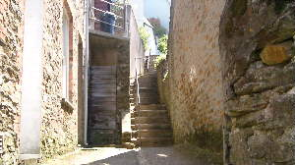
Walk up the street from the quay for a few metres then turn left and follow signs marked as Hall's Walk.
A few metres of level walking give way to walking uphill, up some quite steep steps. Thankfully the steps grow less steep quite quickly and before long you will leave the houses of Polruan behind and walk gently uphill through a wooded and consequently nicely shaded area.

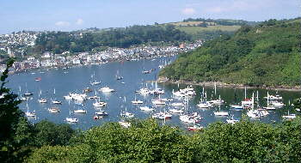
You will be walking along the southern slopes of a tidal inlet, shown on the map as Pont Pill with the lower reaches full of boats.
From time to time the local council has cut back the trees to give nice views of Pont Pill and across to Fowey.
Continue to enjoy the shade of the trees along the side of the wooded valley until you emerge out onto a road with a fork ahead.
One country road leads downhill to the lovely village called Pont with the right hand fork across to the very old Lanteglos Church and a farm on the right hand side, aptly named Churchdown Farm.
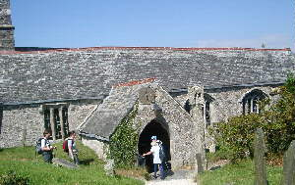
This church is over 500 yrs old and is full of history as you might expect.
These days it is best known as the church where Daphne Du Maurier was married in 1934.
Daphne du Maurier loved this area and it is not difficult to see why, she lived and wrote some of her best novels at Menabilly on the Fowey side of this lovely estuary and river.
Take the opportunity of calling into the church and looking at the many religious artifacts.
There is a lovely old carved granite standing stone just outside the entrance to the farm.
Leave the church and walk by Churchdown Farm on down a dip and then another sharp climb up the narrow country road.
After a short distance of uphill walking you will leave the road and follow a footpath sign which leads north east initially along a roughish track and then along an earth track and through fields. The track descends steeply for a short distance and this section could be quite difficult when wet.
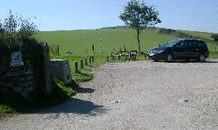
Pass by a couple of houses and then out onto a road which runs down from Frogmore down to Pont. You will have about 0.5 km of road walking at this point uphill to a road junction and then right and up by Frogmore Farm and to the Frogmore NT car park.
This NT car park has its own toilet and grassy seating area and is a nice point to have a short afternoon break.
Follow a short track across towards a path which leads on across to another road and beyond that down to Lantivet Bay.
The first short track simply cut the corner between two country lanes.
At the end of the track, turn left onto the narrow land and don’t follow the track on down to the coast.
Walk east along the narrow road for about 0.5 km until you came to a right of way sign and stone steps on the right hand side of the road cut into a steep bank which leads you up and over into a field.
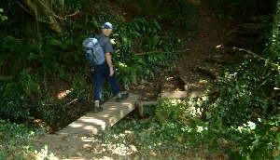
Walk by Trevarder Farm off to your left and you will come to a gate which leads you to a very short but steep descent (ditto) into a wooded valley.
At the bottom of the track it turns left for a few yards and there is a small wooden bridge over a stream and then uphill again and out of the wooded valley through a gate and into a field.
Keep to the side of a field and ahead you can see the tower of Lansallos Church, a few hundred metres ahead.
Over another stile or two and cross over a stile with the church to your right hand side.
Skirt around by a National Trust camping site and over a stile and onto the road at the point by the church. A 10.30am start from this point would bring you back here around 4pm allowing for some stops.
Turn left onto the road and head the short distance back to the car park.
ONE LAST THING - PLEASE CONTRIBUTE TO THE HONESTY BOX SO OTHERS MAY ENJOY THE WALK TOO.

